**Experiment-1**

**1.i) AIM:** Implement the data link layer framing method “character-stuffing”

**THEORY:**  
Coming to the Character Stuffing, DLESTX and DLEETX are used to denote start and end of character data with some constraints imposed on repetition of characters as shown in the program below clearly.

**PROCEDURE:**

**Identify Special Characters**: Identify the special characters that need to be escaped, such as DLE and STX.

**Scan Data**: Traverse the data stream for occurrences of DLE or STX.

**Insert DLE Prefix**: For each occurrence of DLE or STX, insert an additional DLE before it. For example, replace DLE with DLE DLE and STX with DLE STX.

**Transmit Data**: Send the modified data stream.

**De-stuff on Reception**: At the receiver end, remove the extra DLE prefix before processing the data.

**SOURCE CODE: // CHARACTER STUFFING**

**PROGRAM:**

#include<stdio.h>

#include<string.h>

void charc(void);  
void main()  
{  
int choice;  
while(1)  
{  
printf("\n\n\n1.character stuffing");  
printf("\n\n2.exit");  
printf("\n\n\nenter choice");  
scanf("%d",&choice);  
printf("%d",choice);  
if(choice>2)  
printf("\n\n invalid option....please renter");  
switch(choice)  
{  
case 1:  
charc();  
break;  
case 2:  
exit(0);  
}  
}  
}  
void charc(void)  
{  
char c[50],d[50],t[50];  
int i,m,j;  
clrscr();  
printf("enter the number of characters\n");  
scanf("%d",&m);  
printf("\n enter the characters\n");  
for(i=0;i<m+1;i++)  
 {  
scanf("%c",&c[i]);  
}  
printf("\n original data\n");  
for(i=0;i<m+1;i++)  
 printf("%c",c[i]);  
d[0]='d';  
d[1]='l';  
d[2]='e';  
d[3]='s';  
d[4]='t';  
d[5]='x';  
for(i=0,j=6;i<=m;i++,j++)  
 {  
if((c[i]=='d'&&c[i+1]=='l'&& c[i+2]=='e'))  
{  
d[j]='d';  
j++;  
d[j]='l';  
j++;  
d[j]='e';  
j++;  
m=m+3;  
}  
d[j]=c[i];  
}  
m=m+6;  
m++;  
d[m]='d';  
m++;  
d[m]='l';  
m++;  
d[m]='e';  
m++;  
d[m]='e';  
m++;  
d[m]='t';  
m++;  
d[m]='x';  
m++;  
printf("\n\n transmitted data: \n");  
for(i=0;i<m;i++)  
 {  
printf("%c",d[i]);  
}  
for(i=6,j=0;i<m-6;i++,j++)  
 {  
if(d[i]=='d'&&d[i+1]=='l'&&d[i+2]=='e'&&d[i+3]=='d'&&d[i+4]=='l'&&d[i+5]=='e')  
i=i+3;  
t[j]=d[i];  
}  
printf("\n\nreceived data:");  
for(i=0;i<j;i++)  
 {printf("%c",t[i]);  
}  
}

**OUTPUT:**   
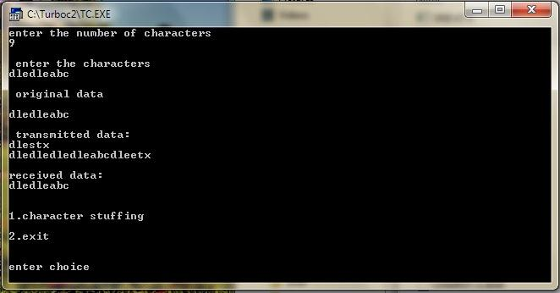

**ii).** **AIM:** Implement the data link layer framing method “bit stuffing”

**Theory:**  
Security and Error detection are the most prominent features that are to be provided by any application which transfers data from one end to the other end. One of such a mechanism in tracking errors which may add up to the original data during transfer is known as Stuffing. It is of two types namely Bit Stuffing and the other Character Stuffing. Coming to the Bit Stuffing, 01111110 is appended within the original data while transfer of it. The following program describes how it is stuffed at the sender end and de-stuffed at the reciever end.

**PROCEDURE:**

**Identify Bit Patterns**: Determine the bit pattern that needs to be stuffed (e.g., a sequence of five consecutive 1s).

**Scan Data**: Traverse the bit stream looking for occurrences of the identified pattern.

**Insert Stuffed Bits**: Insert an extra 0 bit after the identified pattern to break up the sequence (e.g., replace 11111 with 111110).

**Transmit Data**: Send the modified bit stream over the network.

**De-stuff on Reception**: At the receiver end, remove the extra 0 bit that was inserted to restore the original data.

**SOURCE CODE: // BIT STUFFING**

**PROGRAM:**

#include<stdio.h>

#include<string.h>

main()  
{  
int a[15];  
int i,j,k,n,c=0,pos=0;  
clrscr();  
printf("\n Enter the number of bits");  
scanf("%d",&n);  
printf("\n Enter the bits");  
for(i=0;i<n;i++)  
 scanf("%d",&a[i]);  
for(i=0;i<n;i++)  
 {  
if(a[i]==1)  
{  
c++;  
if(c==5)  
{  
pos=i+1;  
c=0;  
for(j=n;j>=pos;j--)  
{  
k=j+1;  
a[k]=a[j];  
}  
a[pos]=0;  
n=n+1;  
}  
}  
else  
c=0;  
}  
printf("\n DATA AFTER STUFFING \n");  
printf(" 01111110 ");  
for(i=0;i<n;i++)  
 {  
printf("%d",a[i]);  
}  
printf(" 01111110 ");  
getch();  
}

**OUTPUT:**  
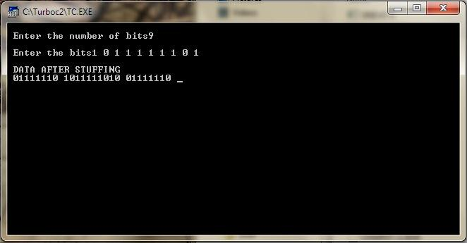

**Questions for Discussions(Viva)**

### **1. What is a computer network?**

**Answer:**  
A computer network is a system of interconnected devices that communicate and share resources like files, printers, and internet access.

### **2. What is the OSI model?**

**Answer:**  
The OSI model is a seven-layer framework that standardizes network functions to allow diverse communication systems to communicate using standard protocols.

### **3. What is an IP address?**

**Answer:**  
An IP address is a unique identifier assigned to each device on a network, used to locate and communicate with devices across networks.

### **4.What is the Data Link Layer?**

**Answer:**  
The Data Link Layer is the second layer of the OSI model, responsible for ensuring reliable data transfer between two directly connected nodes by managing error detection, flow control, and frame synchronization.

### **5.What is framing in the Data Link Layer?**

**Answer:**  
Framing is the process of dividing data into frames, which include headers and trailers for error detection and addressing, ensuring organized data transmission.